**Abstract Template for International SPACC Symposium**

Office Use

A. Author,1,* B. Author,1 and C. Author2

1 *The Author affiliation, department, city, Country*

2 *The Author affiliation, department, city, Country if different*

*E-mail: your_address@xx.xxxx.xxx

The authors are encouraged to submit a camera-ready abstract [A4-size (210 x 297 mm) with margins described in Fig. 1, or within a frame of 170 x 240 mm]. The abstract must be written in English. Use Times New Roman font. In the PDF file case, all fonts should be embedded in the file. The font size should be boldfaced 14 point for the title. The presenter name must be underline. Text must be typed with a Times New Roman, single spacing, 12 pt in regular type. Alignment must be formatted to full justification.

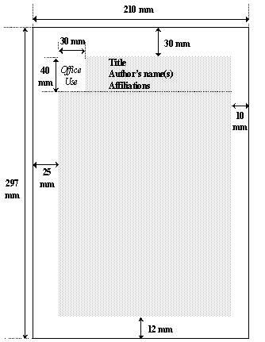

Fig.1 Margins for the Abstract template.

The abstract should be completed within 1 page with figures, tables and references. As the submitted abstract will be printed and reproduced directly without any editing, special care should be taken to ensure high quality of text and diagrams.



Fig.2 SPACC logo

Table 1

|  |  |
| --- | --- |
| XXX | XXX |
| xxx | xxx |
| **xxx** | **xxx** |

[1] A. Author and B. Author: “Title of paper,” Journal Name, vol., startpage-endpage (year).

[2] A. Author, Title of book (Publisher), Chapter, (year).